**Name:**

**Lab Course Title:**

**Lab Course Code:**

**Semester: 3rd Semester (Spring 2020)**

**REG #.**

***Lab Report***

***Engineering Drawing & CAD Lab***

**Department of Computer system Engineering**



**Submitted to:**

**Engr. Asim Ahmad Riaz**



**University of Engineering & Technology, Peshawar**

**Department of Computer System Engineering**

**Engineering Drawing & CAD Lab**

Dated: 07/07/2020

**Lab Report # 01**

**Introduction to AutoCAD**

* This lab report will contain introduction and definitions drawing and engineering drawing, history and versions of AutoCAD, Benefits and limitation of AutoCAD, CAD softwares, recommended books and software used for this Lab
* Mention figures and images (if required)
* The heading should be bold (font style: Arial – font size: 12)
* Don’t underline the heading
* Use Time New Roman style for description unbold and font size should be 10

Use google search and book and lecture # 01



**University of Engineering & Technology, Peshawar**

**Department of Computer System Engineering**

**Engineering Drawing & CAD Lab**

Dated: 07/07/2020

**Lab Report # 02**

**Introduction to AutoCAD Graphical User Interface (GUI) and General commands, setting up drawing sheet, Units & toolbars**

* This lab report will contain; what is GUI and mark different parts of AutoCAD graphical screen.

1. Title Bar 2. Menu Bar 3.The Standard toolbar

4. Command prompt area

* Write step-wise procedure for Launching AutoCAD, setting workspace, Putting the User Interface to work, Setting toolbars for quick use etc.
* Explain each component and toolbar along with figures
* Mention figures and images.
* The heading should be bold (font style: Arial – font size: 12)
* Don’t underline the heading
* Use Time New Roman style for description unbold and font size should be 10

Use google search and book and lecture # 01



**University of Engineering & Technology, Peshawar**

**Department of Computer System Engineering**

**Engineering Drawing & CAD Lab**

Dated: 07/07/2020

**Lab Report # 03**

**Setting Up Drawing unit, Drawing sheet, Dimension style and Text style**

Write down a stepwise procedure for Setting Up Drawing unit and Drawing sheet, Dimension style and Text style along with figure and images if required

* Mention figures and images (if required)
* The heading should be bold (font style: Arial – font size: 12)
* Don’t underline the heading
* Use Time New Roman style for description unbold and font size should be 10

Use google search and book and lecture # 01



**University of Engineering & Technology, Peshawar**

**Department of Computer System Engineering**

**Engineering Drawing & CAD Lab**

Dated: 07/07/2020

**Lab Report # 04**

**Opening, Saving, and Printing AutoCAD sketches & Introduction to basic commands (Zoom and Pan)**

Write down a stepwise procedure for Opening, Saving, and Printing AutoCAD sketches along with figure and images if required

Discuss each option in zoom command and Pan in this report alongwith figures and images

* Mention figures and images (if required)
* The heading should be bold (font style: Arial – font size: 12)
* Don’t underline the heading
* Use Time New Roman style for description unbold and font size should be 10

Use google search and book and lecture # 01



**University of Engineering & Technology, Peshawar**

**Department of Computer System Engineering**

**Engineering Drawing & CAD Lab**

Dated: 07/07/2020

**Lab Report # 05**

**Introduction to Status bar and function of different toggle button in status bar**

*(Snap, Grid, Ortho, Polar, Osnap, Otrack, Dyn)*

**Discuss function of** Each status bar button along with figure

* Mention figures and images (if required)
* The heading should be bold (font style: Arial – font size: 12)
* Don’t underline the heading
* Use Time New Roman style for description unbold and font size should be 10

Use google search and book and lecture # 02



**University of Engineering & Technology, Peshawar**

**Department of Computer System Engineering**

**Engineering Drawing & CAD Lab**

Dated: 07/07/2020

**Lab Report # 06**

**Introduction to 3D workspace to 2D, Command Prompt window & Repetition of commands, UCS icon in 2D,** **Blue grip & its size (stretch, lengthen), cross hair (pick box & Size), Selection Window (From Right to Left & Left to Right)**

Discuss functions and Write down a stepwise procedure for using the above options

* Mention figures and images (if required)
* The heading should be bold (font style: Arial – font size: 12)
* Don’t underline the heading
* Use Time New Roman style for description unbold and font size should be 10

Use google search and book and lecture # 02



**University of Engineering & Technology, Peshawar**

**Department of Computer System Engineering**

**Engineering Drawing & CAD Lab**

Dated: 07/07/2020

**Lab Report # 07**

**Introduction to AutoCAD Coordinate system**

**(Absolute, Relative & Polar Coordinate System)**

Discuss each Coordinate system in detail with figure and images if required

* Mention figures and images (if required)
* The heading should be bold (font style: Arial – font size: 12)
* Don’t underline the heading
* Use Time New Roman style for description unbold and font size should be 10

Use google search and book and lecture # 02



**University of Engineering & Technology, Peshawar**

**Department of Computer System Engineering**

**Engineering Drawing & CAD Lab**

Dated: 07/07/2020

**Lab Report # 08**

**Introduction to Draw Toolbar and different commands**

Discuss each command in draw tool bar in detail with figure and images

* Mention figures and images (if required)
* The heading should be bold (font style: Arial – font size: 12)
* Don’t underline the heading
* Use Time New Roman style for description unbold and font size should be 10

Use google search and book and lecture # 03 & 04



**University of Engineering & Technology, Peshawar**

**Department of Computer System Engineering**

**Engineering Drawing & CAD Lab**

Dated: 07/07/2020

**Lab Report # 09**

**Introduction to Modify Toolbar and different commands**

Discuss each command in Modify tool bar in detail with figure and images

* Mention figures and images (if required)
* The heading should be bold (font style: Arial – font size: 12)
* Don’t underline the heading
* Use Time New Roman style for description unbold and font size should be 10

Use google search and book and lecture # 03 & 04



**University of Engineering & Technology, Peshawar**

**Department of Computer System Engineering**

**Engineering Drawing & CAD Lab**

Dated: 07/07/2020

**Lab Report # 10**

**Introduction to Dimension Toolbar and its different commands**

Discuss each command in Dimension tool bar in detail with figure and images

* Mention figures and images (if required)
* The heading should be bold (font style: Arial – font size: 12)
* Don’t underline the heading
* Use Time New Roman style for description unbold and font size should be 10

Use google search and book and lecture # 03 & 04



**University of Engineering & Technology, Peshawar**

**Department of Computer System Engineering**

**Engineering Drawing & CAD Lab**

Dated: 07/07/2020

**Lab Report # 11**

**Practicing 2D figure**

**Figure # 01**

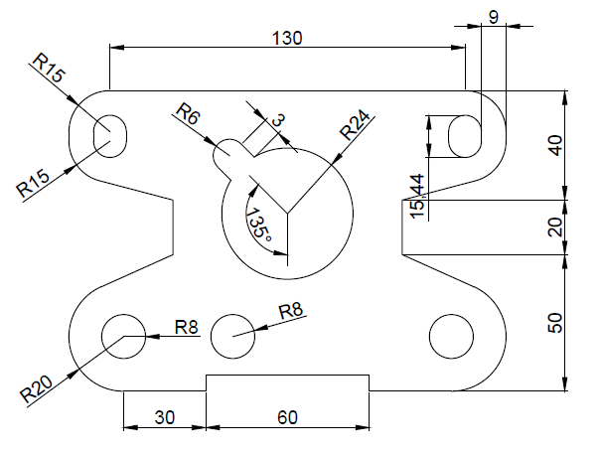

**Figure # 02**

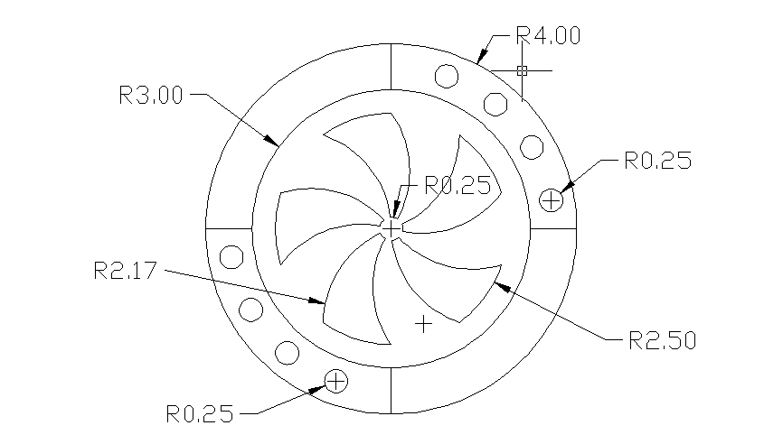

**Draw figure 1 & 2 in AutoCAD and write down the construction step in sequence for each figure**

**Attach the drawn figure with dimension in your lab reports**

**University of Engineering & Technology, Peshawar**

**Department of Computer System Engineering**

**Engineering Drawing & CAD Lab (ME-104L)**

Dated: 07/07/2020

(Update the date accordingly)

**Lab Report # 12**

**Engineering Drawing Template creation and title block drafting in AutoCAD**

Discuss the following in this Lab report

1. Learning objectives:
2. Discuss Drawing Sheet and its dimensions (with figures/images)
3. Orientation of Drawing sheet (with figures/images)
4. Title block and its components with figure and images (You can find multiple templates and title blocks in ND Butt, 49th Edition)

*(Attach a sample of template that you created in AutoCAD, which include your name, department, university logo, registration no., etc.)*

1. What is field in AutoCAD
2. Discuss step wise procedure for creating template and title block in detail with figure and images

**Instruction for Lab Report**

* It is important to Mention figures/images (if required)
* The heading should be bold (font style: Arial – font size: 10)
* Don’t underline the headings
* Use Time New Roman style for description, unbold and font size should be 10

***Helping Material: Class Lecture, Video Lecture, Use google search and book and slides for writing this Lab Report***

**University of Engineering & Technology, Peshawar**

**Department of Computer System Engineering**

**Engineering Drawing & CAD Lab (ME-104L)**

Dated: 07/07/2020

(Update the date accordingly)

**Lab Report # 13**

**Introduction to Layers in AutoCAD**

Discuss the following in this Lab report

1. Learning objectives:
2. Discuss Layers and layers properties manager (with figures/images)
3. Layers settings (with figures/images)
4. Attach snapshot / image of the layers created and practiced by you

**Instruction for Lab Report**

* It is important to Mention figures/images (if required)
* The heading should be bold (font style: Arial – font size: 10)
* Don’t underline the headings
* Use Time New Roman style for description, unbold and font size should be 10

***Helping Material: Class Lecture, Video Lecture, Use google search and book and slides for writing this Lab Report***

**University of Engineering & Technology, Peshawar**

**Department of Computer System Engineering**

**Engineering Drawing & CAD Lab (ME-104L)**

Dated: 07/07/2020

(Update the date accordingly)

**Lab Report # 14**

**Introduction to 3D modeling, Primitive solids and general solid drafting (AutoCAD V. 2020)**

Discuss the following in this Lab report

1. Learning objectives: (Write by yourself)
2. What is geometric modeling and its types i.e. wireframe etc.
3. Discuss views (Isometric view, orthographic view, oblique view etc.)
4. **Discuss 1st angle of Projection vs 3rd angle of projection**
5. Discuss Primitive solid with figures (Box, Cylinder, Sphere, Cone and pyramid, Polysolids etc.)
6. What is Extrude command, Press-pull commad, sweep, loft, revolve commad.

**Instruction for Lab Report**

* It is important to Mention figures/images (if required)
* The heading should be bold (font style: Arial – font size: 10)
* Don’t underline the headings
* Use Time New Roman style for description, unbold and font size should be 10

***Helping Material: Class Lecture, Video Lecture, Use google search and book and slides for writing this Lab Report***

**University of Engineering & Technology, Peshawar**

**Department of Computer System Engineering**

**Engineering Drawing & CAD Lab (ME-104L)**

Dated: 07/07/2020

(Update the date accordingly)

**Lab Report # 15**

**Introduction to 3D commands and 3D solid editing**

Discuss the following in this Lab report

1. Learning objectives: (Write by yourself)
2. Discuss 3D commands (Read last chapter for ND butt, 49th edition)
3. Discuss 3D solid editing (Union, subtract, intersect, shell, slice, etc)
4. Discuss visual styles, view controls and 3D orbit.

**Instruction for Lab Report**

* It is important to Mention figures/images (if required)
* The heading should be bold (font style: Arial – font size: 10)
* Don’t underline the headings
* Use Time New Roman style for description, unbold and font size should be 10

***Helping Material: Class Lecture, Video Lecture, Use google search and book and slides for writing this Lab Report.***

**University of Engineering & Technology, Peshawar**

**Department of Computer System Engineering**

**Engineering Drawing & CAD Lab (ME-104L)**

Dated: 07/07/2020

(Update the date accordingly)

**Lab Report # 16**

**Dimensioning of 3D Part dimensioning**

Discuss the following in this Lab report

1. Learning objectives: (Write by yourself)
2. Discuss stepwise procedure for 3D part annotation (Watch video lecture)

**Instruction for Lab Report**

* It is important to Mention figures/images (if required)
* The heading should be bold (font style: Arial – font size: 10)
* Don’t underline the headings
* Use Time New Roman style for description, unbold and font size should be 10

***Helping Material: Class Lecture, Video Lecture, Use google search and book and slides for writing this Lab Report***



**University of Engineering & Technology, Peshawar**

**Department of Computer System Engineering**

**Engineering Drawing & CAD Lab (ME-104L)**

Dated: 07/07/2020

(Update the date accordingly)

**Lab Report # 17**

**Practicing 3D figure**

**Figure # 01**

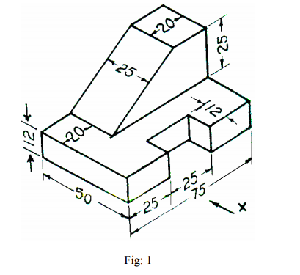

**Figure # 02**

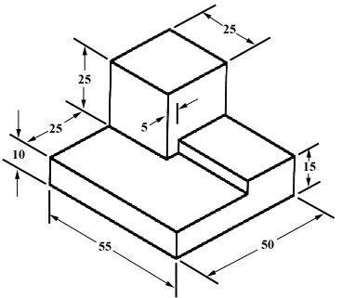

**Figure # 03**

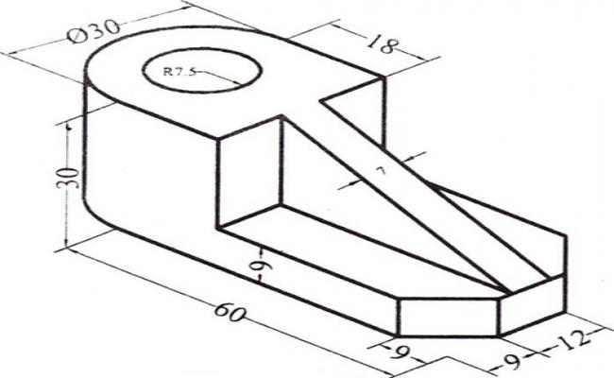

**Draw figure 1, 2 and 3 in AutoCAD and write down the construction step in sequence for each figure**